Project Design Phase-II
Technology Stack (Architecture & Stack)

Date | 28 September 2026
Team ID | SWTID-2026-8954
Project Name | AI StudyBuddy
Maximum Marks | 4 Marks

Technical Architecture
Architecture Flow:
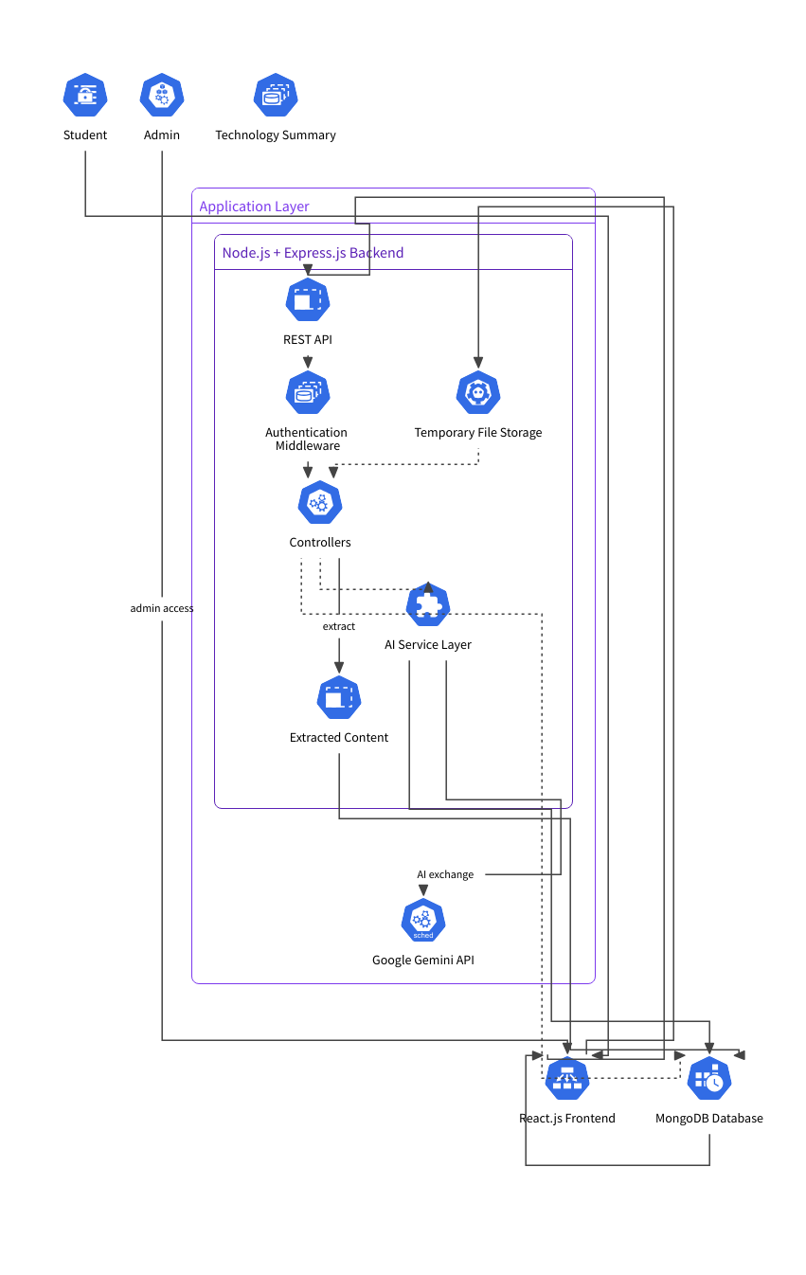

Table-1: Components & Technologies
S.No. | Component | Description | Technology
1 | User Interface | Provides the interface through which students and administrators interact with the application, including login, dashboard, study material and learning-resource features. | React.js, HTML, CSS, JavaScript
2 | Application Logic-1 | Handles user registration, login, password verification, JWT authentication and role-based access control. | Node.js, Express.js, bcryptjs, JSON Web Token (JWT)
3 | Application Logic-2 | Handles study material upload, storage, retrieval and deletion, and manages material-related operations. | Node.js, Express.js, Multer, Mongoose
4 | Application Logic-3 | Processes study materials and communicates with the AI service to generate summaries, flashcards, quizzes and personalized study plans. | Node.js, Express.js, Google Gemini API
5 | Database | Stores user accounts, study materials and generated learning resources such as summaries, flashcards, quizzes and study plans. | MongoDB, Mongoose
6 | Cloud Database | Provides remotely hosted database storage for application data during development and testing. | MongoDB Atlas
7 | File Storage | Temporarily stores uploaded study material files for processing before the extracted content is stored in the database. | Local Filesystem, Multer
8 | External API-1 | Generates AI-powered summaries, flashcards, quizzes and personalized study plans from study material. | Google Gemini API
9 | External API-2 | No additional external API is required in the current version of AI StudyBuddy. | Not Applicable
10 | Machine Learning / AI Model | Processes study material and generates learning resources based on the student's requirements. | Google Gemini AI
11 | Infrastructure (Server / Cloud) | Runs the backend application locally during development and testing. MongoDB data is hosted using MongoDB Atlas. | Node.js Server, Localhost, MongoDB Atlas

Table-2: Application Characteristics
S.No. | Characteristics | Description | Technology
1 | Open-Source Frameworks | Uses open-source technologies for application development, backend APIs, database interaction and authentication. | React.js, Node.js, Express.js, Mongoose
2 | Security Implementations | User authentication is implemented using JWT. Passwords are securely hashed using bcryptjs. Role-based access control protects administrative operations, and protected APIs require authentication. | JWT, bcryptjs, RBAC, Express middleware
3 | Scalable Architecture | The application separates the user interface, backend API/business logic and database into different layers. The architecture can be extended with additional AI features and frontend components as the user base grows. | React.js, Node.js, Express.js, MongoDB
4 | Availability | The application is designed as a web-based system with a REST API. During development it runs on a local server; the architecture can later be deployed on a cloud server for wider availability. | Node.js, Express.js, MongoDB Atlas
5 | Performance | REST APIs are used for communication between the frontend and backend. MongoDB stores application data efficiently, while uploaded files are processed temporarily instead of being permanently stored on the server filesystem. | Express.js, MongoDB, Mongoose, Multer

Architecture Summary
AI StudyBuddy follows a layered three-tier architecture:
Presentation Layer: React.js frontend
↓
Application Layer: Node.js + Express.js REST API, authentication, controllers and AI service
↓
Data Layer: MongoDB + Mongoose
The application also connects the application layer to the Google Gemini API for AI-powered generation of summaries, flashcards, quizzes and personalized study plans.

